The Racial Healing Project Presents

Understanding and Coping with the Effects of Microaggressions and Racial Biases
A yearlong monthly interactive webinar
2:00 – 4:00 pm, Zoom
September 24th, October 22nd, November 19th, 2021
January 28th, February 18th, March 18th, and April 8th, 2022

The Racial Healing Project seeks to engage students, staff, faculty, and administrators at IUPUI in the movement and process of racial healing by aiding participants in understanding the current covert and overt manifestations of racism, reconciling the historical trauma and legacy of racism in the United States, and providing strategies to cope with and combat racism across campus. Visit our website at https://diversity.iupui.edu/initiatives/racial-healing-project/index.html for more information.

Apply for the program by September 20, 2021 at: https://go.iu.edu/3XgG

Questions about the program? Please contact Dr. Ronda Henry Anthony at ronhenry@iupui.edu

Read more about the program speakers
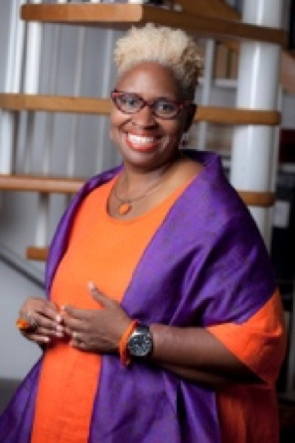
“Dr. Joi” Lewis is CEO and Founder of Joi Unlimited Coaching & Consulting and the Orange Method of Radical Self- Care (Healing Justice) and Radical Hospitality (Social Justice) www.joiunlimited.com. She is the author of the wildly successful book – Healing: The Act of Radical Self-Care. Her work is deeply informed by growing up in East St. Louis, Illinois, and is grounded in healing justice. She is a “bodyworker” for the collective body (systems) and individual bodies (self), Dr. Joi (as many fondly call her) holds space for the discovery of critical pressure points for liberation and healing from trauma through radical self-care. Dr. Joi is a highly sought-after mediator, coach, community healer, social entrepreneur and facilitator of liberation locally, nationally and globally. After a 20+ year career in higher education, she now describes herself as the “Artist-Activist formerly known as Dean Lewis.” Dr. Joi is on a mission to “put healing in the hands of anyone, anywhere.” She is an unapologetic joy instigator, a healer for healers, a certified kemetic and hot vinyasa yoga teacher, and a facilitator of meditation and mindfulness. She also founded the OM Community Coach Program in Healing Justice. She offers courses, coaching programs, healing circles, workshops and retreats on Radical Self-Care, Social Justice, and The Business of Healing for Emotional Laborers, Social Justice Activist & Advocates, Facilitators of Liberation, Yogis, Creatives, Birtworkers, Energy & Light Workers, Meditation & Mindfulness Practitioners, Healers and Helpers. Dr. Joi believes in interrupting oppressor patterns (including her own) with loving kindness so we can reach for our own humanity, and each others’. She has a daily practice of trying to “live” fully in her own body.
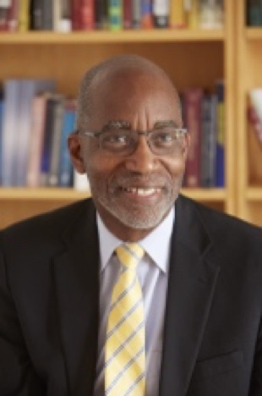
Dr. David R. Williams is an internationally recognized social scientist focused on social influences on health. He has been invited to keynote scientific conferences in Europe, Africa, Australia, the Middle East, South America and across the United States. His research has enhanced our understanding of the complex ways in which socioeconomic status, race, stress, racism, health behavior and religious involvement can affect health. The Everyday Discrimination Scale that he developed is the most widely used measure of discrimination in health studies. With funding from the National Institutes of Health and the sponsorship of the World Health Organization, Dr. Williams directed the South African Stress and Health Study, the first nationally representative study of the prevalence and correlates of mental disorders in sub-Sahara Africa. This study assessed the effects of HIV/AIDS, exposure to racial discrimination and torture during apartheid, on the health of the South African population. He was also a key member of the team that conducted the National Study of American Life, the largest study of mental health disorders in the African American population in the U.S. and the first health study to include a large national sample of Blacks of Caribbean ancestry. Dr. Williams has been involved in the development of health policy at the national level in the U.S. He has served on the National Committee on Vital and Health Statistics and on nine committees for the National Academy of Medicine, including the committee that prepared the Unequal Treatment report. He also served as a member of the MacArthur Foundation’s Research Network on Socioeconomic Status and Health. Dr. Williams has played a visible, national leadership role in raising awareness levels of the problem of health inequalities and identifying interventions to address them. He served as the staff director of the Robert Wood Johnson Foundation’s Commission to Build a Healthier America. This national, independent and nonpartisan health commission was focused on identifying evidence-based non-medical strategies that can improve the health of all Americans and reduce racial and socioeconomic gaps in health. He has also worked on ethnic inequities with the Toronto Public Health Department, the National Health Service in the U.K. and the Pan American Health Organization.

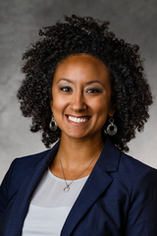
Dr. Bryana French is Associate Professor in the Graduate School of Professional Psychology Morrison Family College of Health at the University of St. Thomas in Minneapolis, Minnesota. She currently teaches MA and PsyD level courses in Diversity Issues, Basic Skills, Dissertation Methods and Writing, and Theories of Career Development. Her practice interests focus on multicultural counseling, social justice advocacy, and sexual violence recovery. Dr. French’s primary research interests focus on sexual coercion and associated psychosocial outcomes among racially diverse young men and women. She has also conducted research on faith-based teen dating violence prevention and alternative educational programming for suspended youth. Her current research projects focus on radical healing for people of color and indigenous people, part of the APA Division 2018 45 presidential initiative. She holds leadership positions in APA including currently serving on the Council of Representatives for Division 17.

