Creating Racially Inclusive Classrooms
A yearlong monthly interactive webinar series
2:00 – 4:00 pm, Zoom
September 24th, October 8th, November 5th, 2021
January 28th, February 18th, March 18th, and April 15th, and May 20th, 2022

The Creating Racially Inclusive Classrooms program changes the way faculty see instruction by helping them apply an equity lens to their courses, which can illuminate the many ways whiteness, power, and bias show up in the classroom and curriculum. Participants will be encouraged to develop skills to ensure all students are included and have the opportunity to learn. The year-long webinar series includes viewing 30-minute informational recordings our speakers make specifically for the program prior to virtual in-person sessions with each speaker to unpack the information shared in the recordings before engaging in group work and discussions.

Apply for the program by September 20 at: https://go.iu.edu/3XgF

Questions about the program? Please contact the Center for Teaching and Learning at thectl@iupui.edu or (317)274-1300.

Read more about the program speakers

The successful author of three books (Turn the Tide, …But I’m Not Racist, and In it for the Long Haul), with over 30 years of experience specializing in conflict resolution, change management and creating inclusive environments, Dr. Kathy Obear is a leading expert in helping to establish socially just spaces where everyone feels valued and respected. As the founder of The Center for Transformation and Change, Dr. Obear has given speeches, facilitated workshops and consulted with top leaders in hundreds of universities, human services organizations and corporations across the United States and internationally with a goal to increase the passion, competence and commitment to create inclusive, socially just environments for all members of the organization.
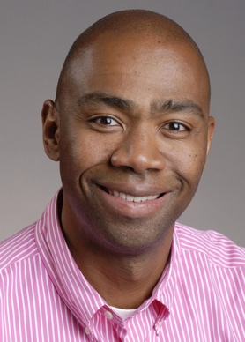
Dr. Cleveland Hayes’s research interest includes the use of Critical Race Theory in Education, Historical and Contemporary Issues in Black Education to include the school to prison pipeline, Teaching and Learning in the Latino Community, Whiteness and the Intersections of Sexuality and Race. Dr. Hayes is an active member of the American Education Research Association (AERA) at the Division Level, SIG level and committee level. He currently, as a program Co-Chair for Division K and is a member of the Special Interest Group Executive Committee. He is also the vice president of the Critical Race Studies in Education. Dr. Hayes’s research can be found in Democracy and Education, Qualitative Studies in Education, and Gender and Education, Urban Review, and Power of Education. In addition, he is the co-editor of the books titled: Unhooking from Whiteness: The Key to Dismantling Racism in the United States and Unhooking from Whiteness: Resisting the Esprit de Corps.

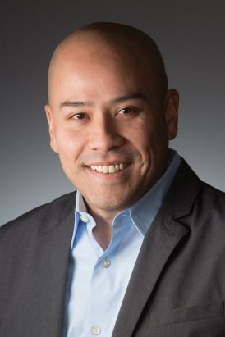
Dr. Samuel D. Museus is a professor of education studies at University of California San Diego. He is also the founding director of the National Institute for Transformation and Equity (NITE). Prior to joining UC San Diego, he taught Asian American studies and higher education at the University of Massachusetts Boston and was a faculty member in higher education at the University of Hawaii at Manoa, the University of Denver, and Indiana University. Dr. Museus has produced over 200 publications and conference presentations focused on diversity and equity, campus environments, and college student outcomes. He is also creator of the Culturally Engaging Campus Environments (CECE; pronounced see-see) Model of College Success among diverse student populations.

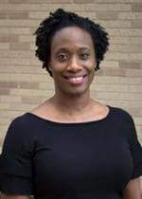
Dr. Chayla Haynes Davison is an Assistant Professor of Higher Education Administration and the recipient of Texas A&M University's Robert and Mavis Simmons Faculty Fellowship. Dr. Haynes Davison's research interests and expertise include: critical and inclusive pedagogy, critical race theory and intersectionality scholarship (i.e., critical race theory, critical race feminism, and intersectionality), and Black women in higher education. She is co-editor of Interrogating Whiteness and Relinquishing Power: White Faculty's Commitment to Racial Consciousness in STEM Classrooms (Peter Lang Publishing) and Race Equity and the Learning Environment: The Global Relevance of Critical and Inclusive Pedagogies in Higher Education (Stylus Publishing). Her scholarship has also been featured in Teachers College Record, the International Journal of Teaching and Learning in Higher Education, the Journal of Critical Scholarship in Higher Education and Student Affairs, and the Journal of Negro Education. Her scholarly contributions were recognized by the American College Personnel Association (ACPA), who named Dr. Haynes Davison an Emerging Scholar Designee in 2016. In 2018, Dr. Haynes Davison and colleagues Drs. Lori Patton Davis and Natasha Croom were recognized by ACPA's Coalition on Women's Identities for their scholarly collaborations on Black women in higher education, receiving their Research and Scholarship Award. Prior to the professoriate, Dr. Haynes Davison served the higher education and student affairs profession for 15 years, as a former Director of Orientation and Family Programs and Services, Director of Student Affairs and Career Services, and Director of Student Activities.

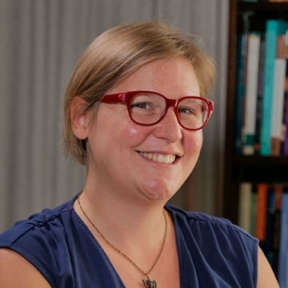
Dr. Marilee Brooks-Gillies is an Assistant Professor of English and director of the University Writing Center. Her areas of interest are cultural rhetorics, writing center theory and practice, rhetorical history and theory, and material rhetorics. Marilee received her PhD in Rhetoric & Writing from Michigan State University in 2013. In her dissertation, Crafting Place: Rhetorical Practice of the Everyday, she worked with a craft group to build a theoretical framework exploring how everyday rhetorical practices contribute to place- and space-making that also enable the negotiation of identity positions. In her free time, Marilee enjoys hiking, crocheting, baking, and reading mystery novels.

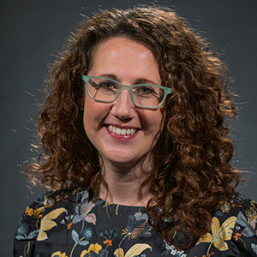
Dr. Krista Hoffmann-Longtin is an Assistant Professor of Communication Studies in the Indiana University School of Liberal Arts at IUPUI, and an Assistant Dean in the Indiana University School of Medicine Office of Faculty Affairs and Professional Development. Her research focuses on communication education in the sciences and health professions, faculty development, and organizational/professional identity. Krista leads Indiana University’s institutional affiliation with the Alda Center for Communicating Science, serves as the co-editor for the Public Library of Science’s Science Communication blog, and runs a graduate minor in Communicating Science at IUPUI. In 2016, Krista was highlighted by the Indianapolis Business Journal as one of their Forty Under 40 young professionals to watch for her work using improvisational theater to teach scientists to communicate more effectively. Prior to earning her graduate degrees, Krista worked for The Weather Channel and Indiana Public Radio. She a BA from Ball State University, an MA in from Purdue University, and a PhD from Indiana University. Krista’s work has been published in Academic Medicine, To Improve the Academy, and the Journal of Faculty Development

Dr. Amy Knopf is a nurse researcher whose research program reflects her commitment to engaging marginalized populations in the resolution of disparities in the prevalence of sexually transmitted infections, including HIV. Her clinical background includes a fellowship in oncology nursing and clinical trials at the National Institutes of Health Clinical Center in Bethesda, MD, and primary care for homeless adults in Washington, DC. She is a graduate of the community-oriented public health practice program at the University of Washington and remains deeply committed to community-engaged research. Dr. Knopf's doctoral work focused on HIV transmission dynamics from a sexual network perspective; specifically, she worked on a pilot study of an intervention designed to disrupt HIV transmission through sexual networks by reducing the prevalence of concurrent (or temporally overlapping) sexual partnerships. As a postdoctoral fellow, Dr. Knopf turned her attention to emerging biomedical HIV prevention technologies, such as pre-exposure prophylaxis (PrEP), and their translation into the everyday lives of populations at risk for HIV infection. Dr. Knopf has two active research projects that explore adolescents’ and parents’ perspectives on the ethical challenges of enrolling minor adolescents in biomedical HIV prevention trials.

